**STUDY OF MAGNETIC LEVITATION SYSTEM ML-01**

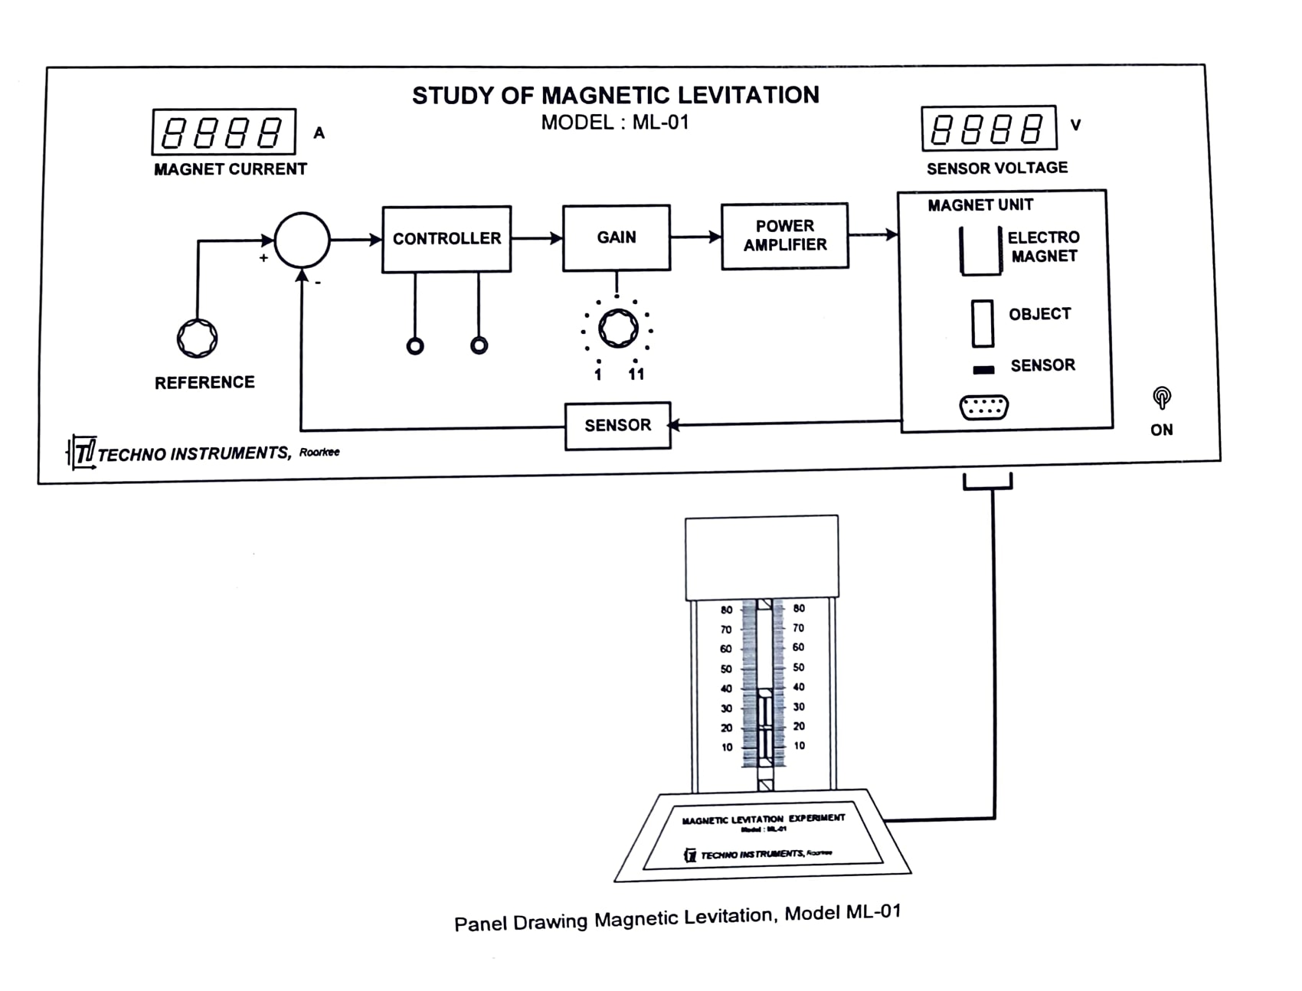

**OBJECTIVE**

Theoretical system and experimental study of a magnetic levitation setup, an inherently unstable system.

**BACKGROUND SUMMARY**

* The magnetic levitation system consists of an electromagnet which pulls an object (a magnetic material) in an upward direction, in the presence of downward gravitational force on it (Fig.1).
* If the magnet current I is adjusted to satisfy the condition, f= mg, the object should, at least theoretically, remain suspended in air.
* In a practical situation, however, even the smallest disturbance would dislocate the balance and the object would either stick to the magnet or fall down to ground.
* Logically therefore the current $i$ needs to be continuously adjusted to keep the object freely suspended in air.
* This task is impossible to be achieved manually, and therefore needs a feedback control loop.
* The basic feedback control scheme is shown in Fig.2. The idea here is to monitor the position of the object continuously and adjust magnet current automatically to ensure the upward force, f, exactly balances the weight of the object, mg, at all times.
* It will however be seen later that due to the unstable dynamics of the object, the automatic control scheme of Fig.2 is not workable and hence a more elaborate controller is required.
* A linearized model of the system is developed next.

**SYSTEM MODEL**

* The electromagnet pulls the object (iron ball) with a force, $f\left(x,i\right)=c{\left(\frac{i}{x}\right)}^{2}, and c=\frac{L_{0}x_{0}}{2}$………………………………(1)
* Here,

$x$ is the distance between the magnet and the object.

$i$ is the current in the magnet coil.

$c$ is the constant of proportionality.

$L_{0}$ is the additional inductance of the magnet coil due to the object placed at the nominal position, $x=x_{0}$.

* The equation of motion of the object is given by

$m\ddot{x}=-c{\left(\frac{i}{c}\right)}^{2}+mg$……………………………………… (2)

Where

$m$ Is the mass of the object, and g is the acceleration due to gravity.

* A linearized form of the above equation may be derived as,

$m\ddot{\tilde{x}}\left(t\right)=-c{\left(\frac{i_{0}}{x_{0}}\right)}^{2}\left\{1+\frac{2\left(\tilde{i}\right)}{i_{0}}-\frac{\tilde{x}\left(t\right)}{x_{0}}\right\}+mg$……………………………. (3)

Where, $\tilde{x}(t)$ and $\tilde{i}(t)$ are the incremental displacement and incremental magnet current around their nominal values, $x_{0}andi_{0}$.

* Since the object is assumed to be at rest at $x=x_{0}$ with $i=i_{0}$,

$c{\left(\frac{i_{0}}{x_{0}}\right)}^{2}=mg,$ Which leads to

$m\ddot{\tilde{x}}\left(t\right)=-\frac{2ci_{0}}{x_{0}}.\tilde{i}\left(t\right)+\frac{2i_{0}^{2}c}{x_{0}^{3}}\tilde{x}(t)$

* Taking Laplace transform and neglecting initial condition,

$\frac{\tilde{x}\left(s\right)}{\tilde{I}\left(s\right)}=-\frac{\frac{2ci_{0}}{mx_{0}^{2}}}{\left(s^{2}-\frac{2ci_{0}^{2}}{mx_{0}^{3}}\right)}$…………………………………………… (4) Is obtained as the dynamics of the object.

* The current- voltage relation of the magnet is given by $\tilde{v}\left(t\right)=R\tilde{i}\left(t\right)+L\frac{d\tilde{i}\left(t\right)}{dt}$, where $\tilde{v}\left(t\right)$ and $\tilde{i}(t)$ are the incremental values of voltage applied to and the current flowing into the electromagnet, and R, L are the coil parameters.
* Taking Laplace transform and neglecting initial conditions, $\tilde{v}\left(s\right)=9R+sL)\tilde{I}\left(s\right),$ 
   and  
  combining the above equations, the system dynamics is given by the transfer function
* $\frac{\tilde{X}\left(s\right)}{\tilde{V}\left(s\right)}=G\left(s\right)=\frac{\left(-\frac{2ci_{0}}{mLx_{0}^{2}}\right)}{\left(s+\frac{R}{L}\right)\left(s^{2}-\frac{2ci_{0}^{2}}{mx_{0}^{3}}\right)}=-\frac{K_{0}}{\left(s+α\right)\left(s^{2}-β^{2}\right)}$…………………………..(5)

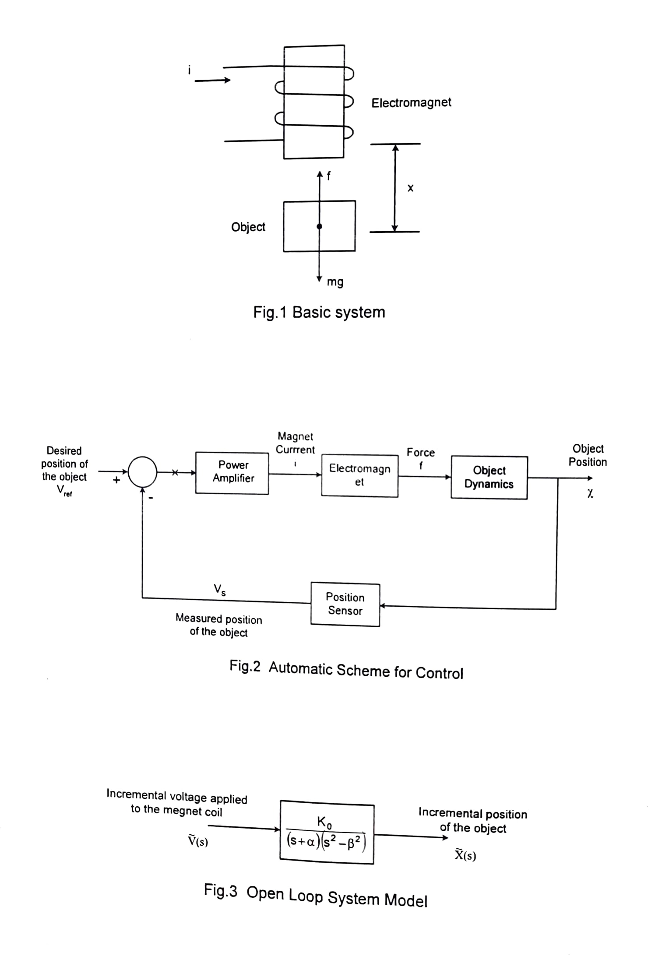

**CONTROLLER SCHEME**

* The above equation may be represented by the block diagram of Fig. 3 which is the open loop system.
* It is clear that the open loop system above is unstable, due to the pole at $s=β$, in the right half of the s-plane.
* Also, connecting a feedback loop on the line of Fig.2 will not lead to a stable closed loop system for any value of forward path gain as may be seen from the root locus diagram of Fig.4.
* This obviously is a proportional controller, which will not stabilize the system.
* In case however a proportional - derivative (PD) controller is used, the revised root locus diagram of Fig.5 indicates the possibility of stabilizing the system and also achieving good transient performance for some range of values of forward path gain.
* The PD controller is assumed to have the transfer function, $G_{c}=(1+T_{ds})$
* The present experiment involves determination of the system parameters, $K_{0}, α and β$ experimentally, and then to design $T_{d}$ the parameter of the controller and choose an appropriate gain.

**PARAMETER DETERMINATION**

* The value of $α$ can be calculated from the magnet parameters, R and L, and using the expression $α=\frac{R}{L}$.
* Since the open loop system, eqn. (5) is unstable, no experimentation is possible directly on it. An alternative method is to use an ad-hoc setting of the PD controller to result in stability. Then the force balance equation, $c{\left(\frac{i}{x}\right)}^{2}=mg,$ is used to calculate an average value of c from measurements of $i$ and x around the nominal equilibrium point $i_{0}, x_{0}$. The mass of the object, m, is known beforehand.
* The constant $K_{0}and β$ are then computed from $K_{0}=\frac{2ci_{0}}{mLx_{0}^{2}} and β=\sqrt{\left(\frac{2ci_{0}^{2}}{mx_{0}^{3}}\right)}$

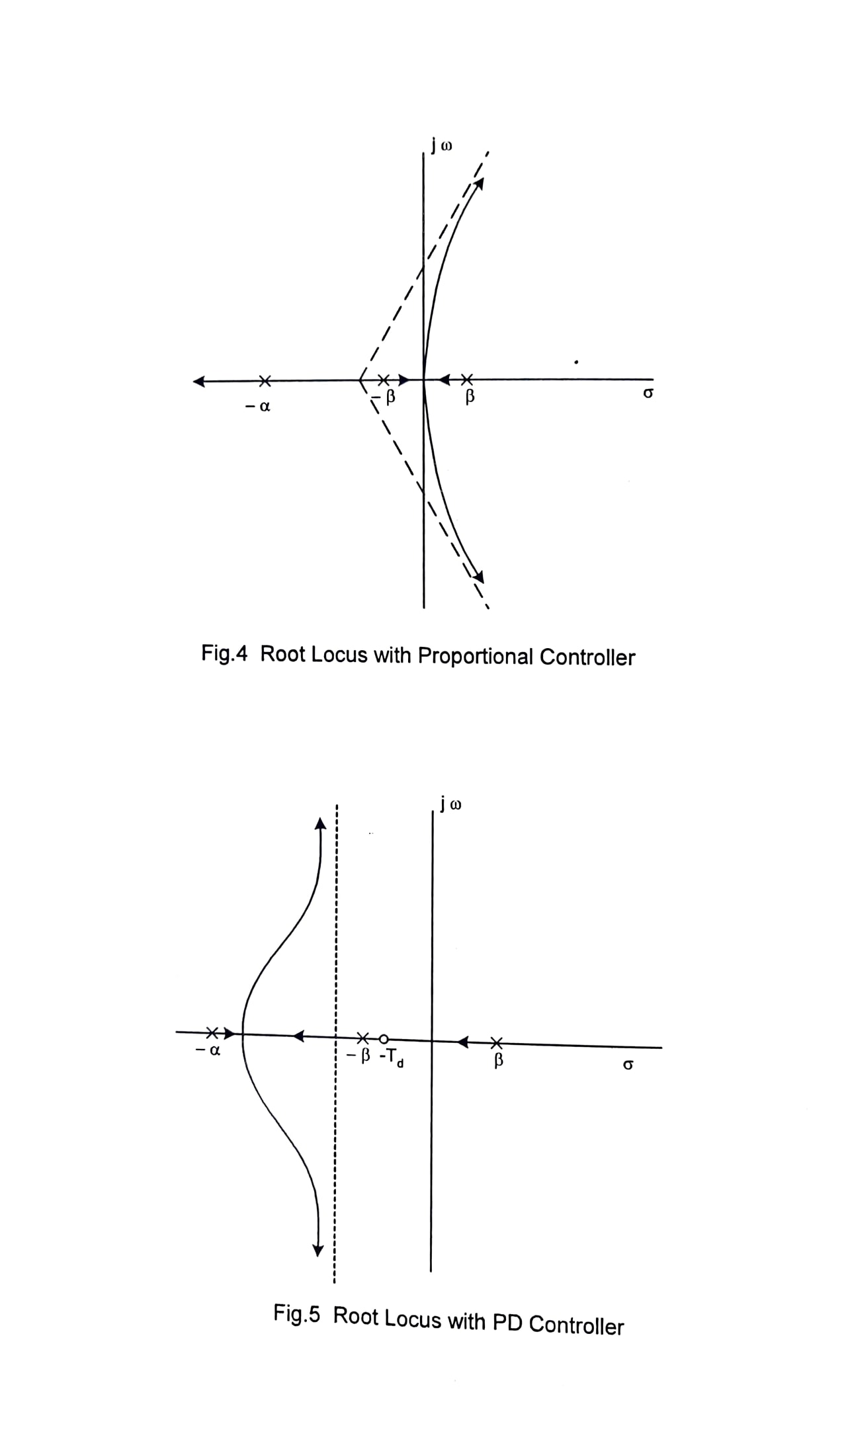

**SYSTEM DESCRIPTION**

* The hardware involved in the various blocks of Fig.2 are described in this section.

**SUSPENDED OBJECT**

* This comprises of two disc magnets $M_{1}and M_{2}$ fixed on the two ends of a height plastic cylinder (Fig. 6).
* While $M_{1}$ is used for providing upward force to pull the object, $M_{2}$ is used for generating the necessary position information through the hall sensor fixed on the base.
* A cylinder made of plastic material ensures proper view and protected movement of the object.
* Note that our earlier analysis refers to iron as the suspended object, in the actual model a magnet $M_{1}$ is used.
* This ensures a better control when the object goes close to the electromagnet.
* Also since the thickness of a magnet is much smaller that $X_{0}$, the calculation are not too the operating much in error.
* Finally, since the system is highly non-linear and we are linearizing around the operating point $X_{0, }i_{0},$ the whole analysis is reasonably accurate eve for a magnet object.

**ELECTROMAGNET**

* A powerful electromagnet is mounted on the top of the guide rod.
* It exerts variable attraction force on $M_{1}$ depending on the current supplied to it.
* The second magnet $M_{2}$, being farther away, is assumed to have a negligible effect on the force.
* The electromagnet is characterized by its winding resistance R and inductance L.

**POWER AMPLIFIER**

* It is a complementary symmetry power amplifier having an internal gain of 2, and capable of providing up to 3 ampere to the electromagnet.
* The external gain of the circuit may be varied from 1 to 11 using the potentiometer on the panel.

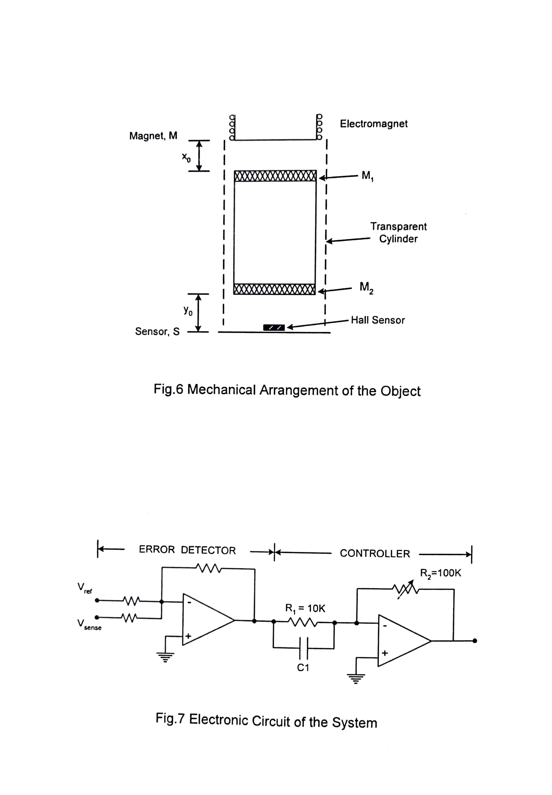

**POSITION SENSOR**

* It is a hall effect device, which generates a electromagnet signal proportional to its distance from $M_{2}.$
* The sensor output is thus a measure of the position of the suspended object.
* Note that due to the highly nonlinear nature of the overall system, we are basically concerned with small deviations around the equilibrium point.
* This enables us to represent the sensor as a constant gain for Computation purposes.

**ERROR DETECTOR AND CONTROLLER**

* The circuit diagram of this section is shown in Fig 7. It performs the tasks of,
* Placing the object to a suitable position which may be taken as the ‘nominal position. This is done by adjusting the reference signal $V_{ref}.$
* Providing a PD controller to ensure system stability, and a simple calculation shown the controller transfer function to be $\frac{R_{2}}{R_{1}}.\left(1+sR_{1}C_{1}\right)$.
* Setting the forward path gain to an appropriate value.

**EXPERIMENTS AND RESULTS**

* The experiments conducted on a typical unit and the results are described below in some detailed.
* The student is expected to repeat the steps on the unit available to him and go through the design.
* Actual results are likely to be somewhat different in each case.

**SYSTEM IDENTIFICATION**

* Standard Parameter values of a typical unit are :  
  Magnet Inductance, $L=8.69×{10}^{-3}h$  
  Magnet Resistance, $R=4.95Ω$  
  Mass of the Object, $m=10×{10}^{-3}Kg$

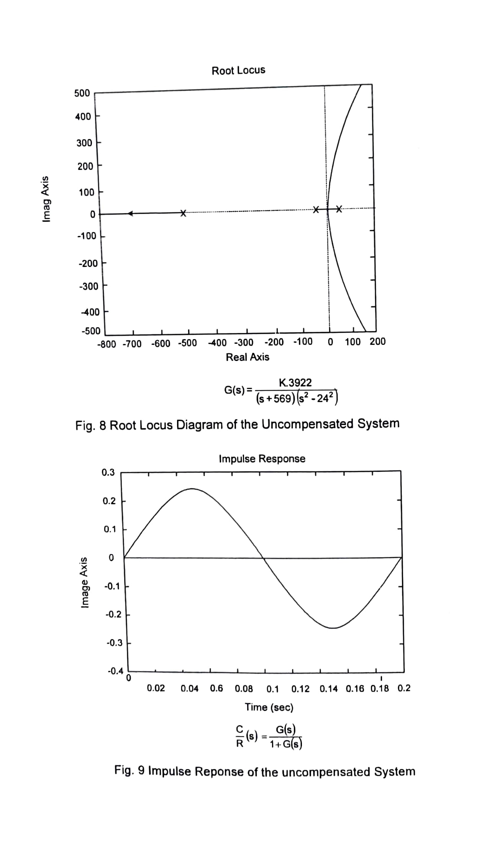

* Based on the parameters of the magnet, the time constant of the coil may be calculated as, $∝=\frac{4.95}{8.69×{10}^{-3}}=569.62 \sec^{-1}$
* The steps below are now followed to determine the remaining parameters.

**Step.1** Connect the PD controller $(C_{1}=2μF)$ and close the feedback loop. Set forward gain to a medium value say 4. The object should now be suspended freely in air by adjusting $V_{ref}.$

**Step.2** Adjust the reference input to move the object in the gap between the magnet and the sensor. This is the nominal position of the object ${[X}_{0}$ is the distance between the object (top marker) and the electromagnet, M and $i_{0}$ is the electromagnet current.]

**Step.3** Record $x_{0}$, $i_{0}$ and calculate c. The mass of the object,

$m=10×{10}^{-3}kg$ (Specified by the manufacturer)

$x_{0}=34mm=0.034m$

$i_{0}=1.15 amp$

$$c=mg{\left(\frac{x_{0}}{i_{0}}\right)}^{2}=10×{10}^{-3}×9.8×{\left(\frac{0.034}{1.15}\right)}^{2}=8.56×{10}^{-5}$$

**Step.4** compute $K_{0}and β\left(Ref to sec. 2.3\right)as,$

$$K_{0}=\frac{2ci_{0}}{mLx_{0}2}=\frac{2g}{Li_{0}}=\frac{2×9.8}{8.69×{10}^{-3}×1.15}=1961$$

$$β=\sqrt{\frac{2ci_{0}^{2}}{mx_{0}^{3}}=}\sqrt{\frac{2g}{x_{0}}}=\sqrt{\frac{2×9.8}{0.034}}=24.00$$

**Step. 5** The transfer function of the system at the nominal position is now written explicitly as

$G\left(s\right)=\frac{2×1961}{\left(s+569\right)\left(s^{2}-{24.00}^{2}\right)}$ (Internal gain of power amplifier=2)

* The forward path transfer function may therefore be written as

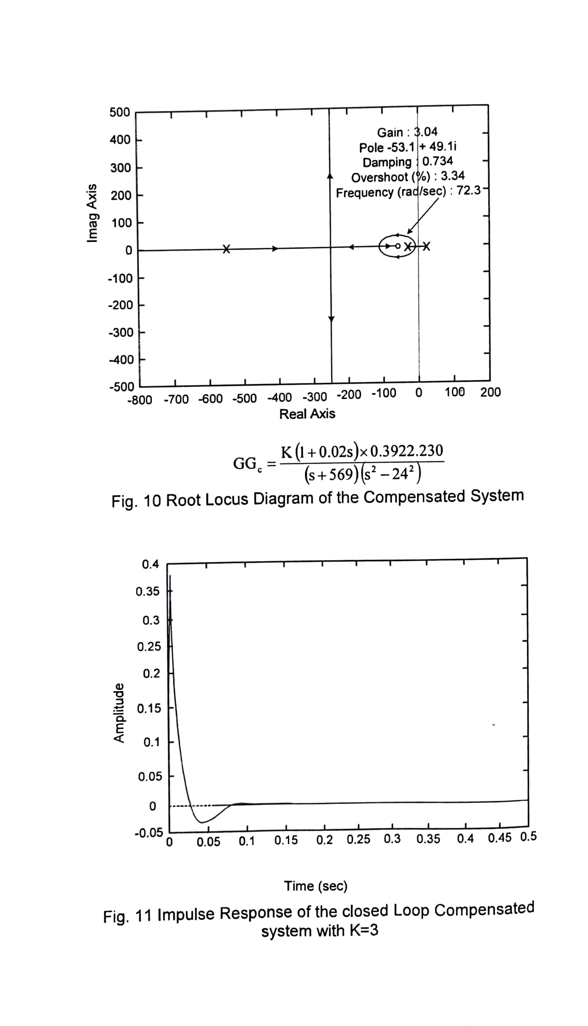

$$K.G\left(s\right)=-\left(\frac{K×3922}{\left(s+569\right)\left(s^{-2}-{24.00}^{2}\right)}\right)$$

* Where K is adjustable between 1 and 11 as explained in section 3.3
* **Step.6** feedback path gain (sensor gain) at the nominal position is found by displacing the object slightly around the nominal position (say $±3 mm)$ and monitoring the change in sensor output.
* $\left(i\right) y_{0}=5mm$ sensor output, $V_{s}=3.62V$
* ${\left(ii\right) y}_{0}+∆y=8mm$ sensor output, $V_{s}+∆V_{s}=3.25V$
* ${\left(iii\right) y}_{0}-∆y=2mm$ sensor output $V_{s}-∆V_{s}=4.63V$
* Average sensor gain $K_{S}=\frac{2∆V_{S}}{2∆y_{0}}=230 V/m$
* The feedback path transfer function may therefore be written as $H\left(s\right)=230$
* **Step.7** Sketch the root locus diagram from the transfer function obtained in Step. 5 and 6 using MATLAB or otherwise, as shown Fig.8. Instability of the closed loop system for all values of open loop gain is obvious, and may also be verified through an impulse response plot as in Fig. 9.  
  Note that since the system has a non-unity feedback path transfer function, the root locus plot must take this into account. Sample MATLAB commands for this purpose are listed below.
$s=tf\left('s^{'}\right)$

* $g=(3922)/((s+569)×(s^{2}-{24}^{2}$));


$h=230;$

$gh=g×h$

$rlocus(gh)$

* $impulse(((g)/(1+g)$), .2)
* Step.8 Choose a suitable closed loop pole location (P) and design a PD controller.
* A good choice may be a zero at S- 50. The compensator transfer function.
* $G_{c}$ =1+0.02s) = 0.02(s+50). With $R_{1}=10KΩ$ (internal), the value of compensator capacitance is Ci 2uF. A revised root locus diagram may be drawn as shown in Fig. 10.
* Note that the system is now stable for K>1.5.  
  Impulse response plot for K - 3 is shown in Fig. 11  
  MATLAB command: $gc=$  
  (1/50)*(s+50)) $rlocus(gh*gc)$ $impilse$
     
  ((($3^{*}g^{*}gc) /$ (1+ $3^{*}gh^{*}gc$)), .0:.0001:.5)   
  Calculate and connect the designed value of capacitor on the panel and operate the system with the computed value of the forward path gain.
* A careful observation of the root locus of Fig.10 would show that the system could be stabilized by using a wide range of capacitors. This may be verified experimentally.  
  Also it might appear that large values of K would be preferred in all cases.  
  This however is not true in the practical situation due to the saturation of the amplifier.

**FURTHER WORK**  
The experimental unit provides the user with an interesting platform to conduct further experimental work. This however is most conveniently done with the support of MATLAB. Some suggestions are:

* Simulate different PD controllers on MATLAB check the root locus diagram impulse response their effect on the unit.
* Attempt lead compensator design and implement it.

**Note:** *Do not expect the experimental performance to match exactly with theoretical prediction. While the theoretical work is valid for linear system only, the experimental system is a mon-linear one, which has been approximated as a linear system for small variation around the operating point.*